Git Version and Config User ID and Email ID:

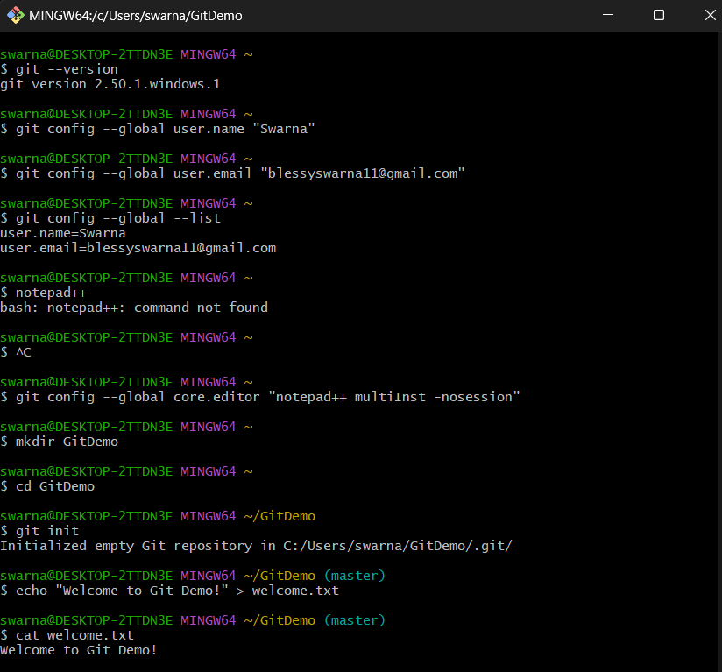

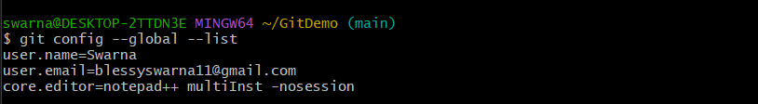

Integrating Notepad++:



Creating New Project and New File:



Welcome.txt is created:

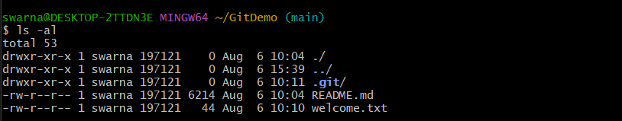

Checking the status:

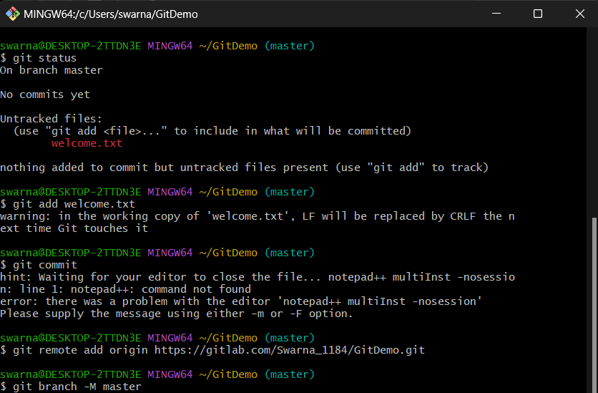

To make the file to be tracked by Git repository





To check if local and “Working Directory” git repository are same, execute git status

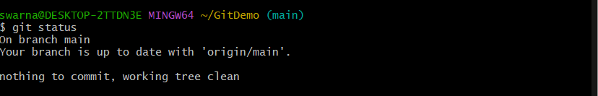

Git pull, Git push, Git Command:

